3D Weather in the Classroom

**Superstorm Sandy**

**1. Overview**

Hurricane Sandy became known as the “Superstorm” because of the rare phenomena of a tropical cyclonic system adopting mid-latitude features aloft and maintaining tropical storm features in the lower levels. Sandy produced catastrophic damages from the Caribbean to Canada.

Tropical cyclone Sandy originally formed as a tropical depression due to a disturbance a couple hundred miles southwest of Kingston, Jamaica on October 22nd, 2012. Tropical Cyclone Sandy first started out as a depression, but on October 25th, Sandy became a category two hurricane and reached peak wind speeds of 100 miles per hour off the southeast coast of Cuba (Figure 1).

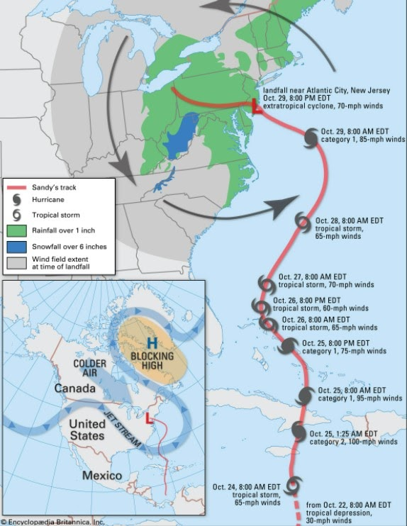

Figures 1. Timeline of Hurricane Sandy’s wind speeds along its path from October 22, 2012, through October 29, 2012.

For a tropical cyclone to develop and continue thriving, there are certain conditions considered favorable for tropical cyclone development that must be current and continue in its path. There must be a previous disturbance a certain distance from the equator, sufficient moisture throughout the atmospheric column, high sea surface temperature of 27 degrees Celsius that extends into the ocean over a depth of 50 meters, and low wind shear (little to no change in wind speed and direction vertically throughout the atmospheric column).

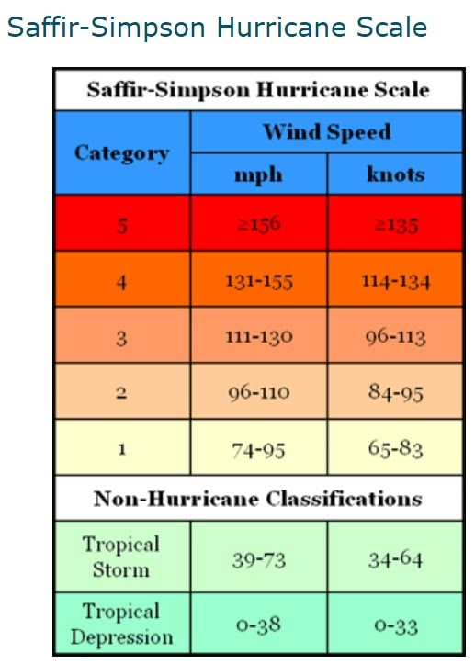

Figure 2. The Saffir-Simpson Hurricane Scale

As Sandy progressed into higher latitudes on its northward path, the wind speeds rapidly increased but then continued to decrease until October 29th. Sandy’s wind speeds increased again, and Sandy became a category one hurricane. Sandy’s category is determined by using the Saffir Simpson Hurricane scale which uses wind speed as an indicator. On this day, Sandy began to succumb to the dynamic forcing of the mid latitudes and began to transition into an extratropical cyclone.

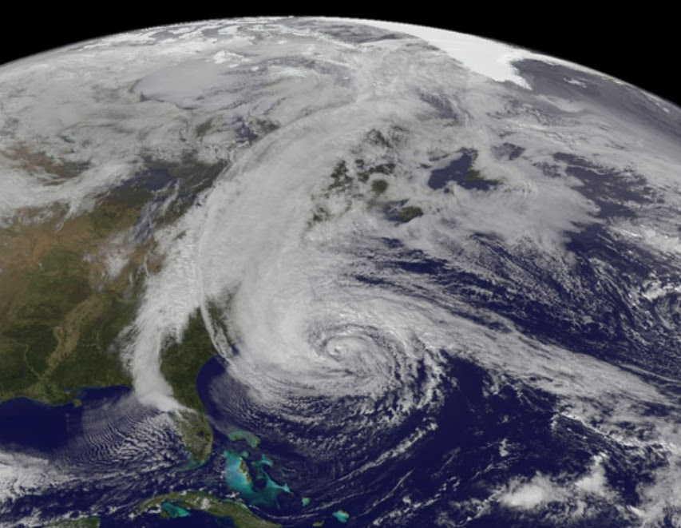  
Figure 3. Satellite imagery of Hurricane Sandy undergoing extratropical transitioning.

Extratropical transitioning is when a tropical cyclone progresses into higher latitudes where strong temperature and pressure gradients have more influence on the winds. On October 29th, Sandy’s path continued towards New Jersey. Meanwhile, a cold front from the west had swept across the country. This cold front crossed paths with Sandy mid extratropical transition. Figure 3 is visible satellite imagery of Sandy undergoing extratropical transitionin. Sandy’s structure is not as defined as a hurricane due to the transitions, and the squall line produced by the cold front can be seen spanning from Canada to Florida (Figure 3).

This frontal system, also can be referred to as a mid-latitude cyclone, occurred downstream of the trough driven by the occlusion of cold, dry air and warm, moist air. Cold, dry air from the continental polar air mass ts way had advected (or moved) across the U.S. When this frontal system collided with Sandy (whose current driving force was latent heat transfer at the time), the top of the storm adopted the frontal systems patterns, meanwhile, the bottom of the storm continued to thrive from the latent heat coming from warm waters underneath. In turn, this resulted in catastrophic amounts of rainfall in New England.

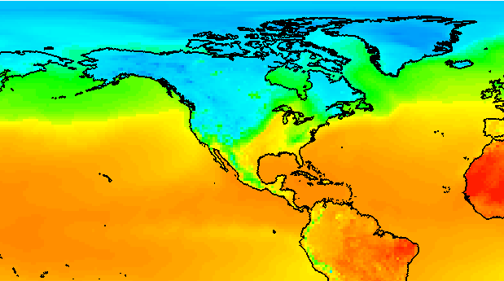

Figure 4. IDV imagery displaying sea surface temperature from October 25th, 2012, at 18 UTC.

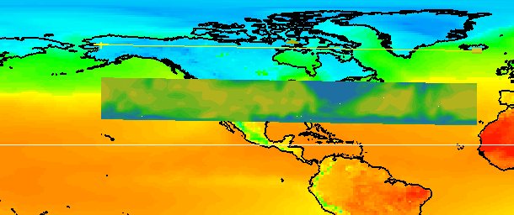

Figure 5. The IDV image shows the sea surface temperatures and the corresponding vertical relative humidity profile from October 25th, 2012, at 18 UTC.

Because Sandy’s fueling force at this time was latent heat transfer from the ocean, sea surface temperatures are shown to demonstrate the horizontal temperature gradient influences by the warm ocean temperate along Sandy’s path (Figure 4). The vertical relative humidity of the atmospheric column can be seen over the Caribbean along with ground and sea surface temperatures (Figure 5). The high relative humidity values correlate with the warm sea surface temperatures, and this process is through the transfer of latent energy.

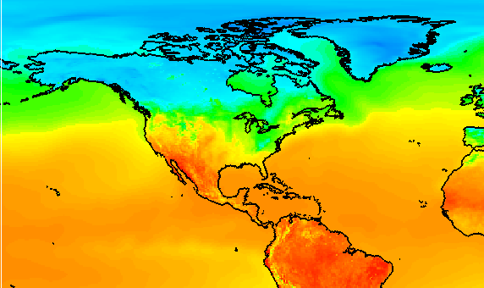

Figure 7. IDV imagery showing the sea surface temperatures from October 29th, 2012, at 18 UTC.

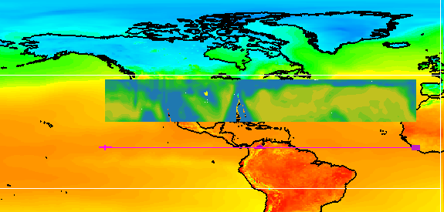

Figure 8. The IDV image shows the sea surface temperature and the corresponding vertical temperature profile from October 29th, 2012, at 18 UTC.

Comparatively, when looking at Sandy on October 29th at 1800Z, the cold front is apparent and visible by recognizing the sharp temperature gradient (blue to green then yellow; Figure 7). Hurricanes are driven by warm water and a moist atmosphere. Extratropical cyclones are driven by frontal airmass systems. The vertical temperature profile shows the temperature gradient between the cold air mass behind the cold front and the warm, moist environment of hurricane Sandy ahead of the cold front (Figure 8).

Sandy was able to maintain tropical storm force winds during the extratropical transition. Along with tropical storm force winds, Sandy made everlasting impacts of flooding from heavy rainfall and/or storm surge. Storm surge is the effect of strong winds from the cyclone approaching the shore and essentially forcing the water to “surge” onto shore. Along with high wind speeds, Sandy caused severe floods mainly in New York City, Long Island, and its suburbs due to storm surge and high amounts of precipitation reaching over 5 inches of rain. It is a rare coincidence of a frontal system occluding with a hurricane and producing catastrophic effects from flooding and winds is why Sandy is known as the “Superstorm”.

**2. IDV Project**

Project filename: “HurricaneSandy.ixv”

* Project data: Filename: “gfsanl_4_20121025_1200_000.grb2” “gfsanl_3_20121029_1800_000.grb2.”
* 0.25°x0.25° Global Forecast System (GFS) analysis data for Oct. 25, 2012 @ 18:00Z. File retrieved from NOAA operational model page for select levels and variables: [NOMADS-NOAA Operational Model Archive and Distribution System](https://nomads.ncep.noaa.gov/)
* Displays:
  + Maps
    - World country outlines.
  + Plan views
    - Surface temperature (°C) on October 25th, 2012 at 12z
    - Surface Temperature (°C ) on October 29th, 2012, at 18z.
  + Cross sections
    - Temperature (°C) on October 29th, 2012, at 18Z.
    - Relative Humidity (%) on October 25th, 2012, at 12 Z.

Features to note:

* + Figure 4 shows sea surface temperatures are high in the Caribbean Ocean and consistently stay warm along Sandy’s northward track.
    - High sea surface temperatures are the source of latent heat transfer which keeps Hurricane Sandy sustained.
  + Figure 5 shows the vertical relative humidity profile from October 25th, 2012, over the Caribbean Sea where Hurricane Sandy undergone intensification.
    - Along with high sea surface temperatures, high amounts of moisture through latent heat transfer are critical to hurricane development.
  + Figure 6 shows the surface temperature from October 29th, 2012. Behind the cold front, lower temperatures are present; meanwhile, ahead of the cold front, warmer air is present.
  + Figure 7 displays the surface temperature and the vertical temperature profile. The vertical temperature profile highlights the vertical extent of the temperature gradient between the cold air mass behind the front and the warm environment of Sandy ahead of the front.

**3. Knowledge Requirements**

* Module 1-1b: Energy Balance Over Ocean and Land
* Module 3-2: Measures of Moisture and Saturation
* Module 5-2: Pressure and Wind at Different Atmospheric Levels
* Module 7-1: Cold and Warm Fronts
* Module 7-3: 3D Structure of Mid-latitude Cyclone

**4. Knowledge Test**

Question 1: The _______ the temperature gradient, the ________ the pressure gradient will be. This type of pressure gradient leads to _______ winds.

* A: stronger, stronger, weaker
* **B: stronger, stronger, stronger**
* C: weaker, weaker, weaker
* D: weaker, weaker, stronger

Question 2: Sandy began extratropical transitioning due to:

* **A: Sandy’s path progressed into high latitudes.**
* B: The cold front overpowered the tropical cyclone.
* C: The water along the Atlantic was too cold.
* D: The wind speeds began to increase.

Question 3: While undergoing extratropical transitioning, the top half of Sandy adopted the features of the anticyclone, and Sandy’s bottom half was dominated by _________.

* A: faster wind speeds
* **B: latent heat transfer**
* C: baroclinic conditions
* D: the cold front

Question 4: What was the source of latent heat?

* **A: warm waters**
* B: high wind speeds
* C: the cold front
* D: high wind shear

Question 5: How are Hurricane Categories determined?

* A: the diameter of the storm
* B: the amount of rainfall
* **C: wind speeds**
* D: damages

Question 6: Why is it important to look at the horizontal and vertical profile of relative humidity?

* **A: Hurricanes are required to have sufficient moisture throughout the atmospheric column spatially including the horizontal and vertical profiles.**

Question 7: For a tropical cyclone to develop, there must be _____ wind shear.

* **A: low**
* B: moderate
* C: high

Question 8: When and where did Sandy reach a category 3?

* A: Atlantic coast east of New Jersey.
* **B: Southeastern coast of Cuba.**
* C: Jamaica
* D: Gulf of Mexico

Question 9: You can recognize the cold front on the IDV by:

* **A: Looking at where the surface temperature gradient is the tightest over the United States.**

Question 10: Sandy was known as the “superstorm” because:

* **A: Tropical cyclone Sandy undergoing extratropical transitioning and a cold front met over the coast of the northeastern U.S. There were memorable and major damages caused by large amounts of rainfall, flooding, and strong winds.**